LT-SPICE LAB Practice 2024

班級: 學號: 姓名: 成績:

- The input signal rising/falling time is 0.5ns. The output loading is 1pf. Please design the 3-input dynamic XOR with the same delay time as 1ns for various input patterns. (0.8ns < T₀₀₀, T₀₀₁, T₀₁₀, T₀₁₁, T₁₀₀, T₁₀₁, T₁₁₀, T₁₁₁ < 1.2ns)

- The input signal rising/falling time is 0.5ns. The output loading is 1pf. Please design the 3-input pseudo nMOS XOR with the same delay time as 1ns for various input patterns. (0.8ns < T₀₀₀, T₀₀₁, T₀₁₀, T₀₁₁, T₁₀₀, T₁₀₁, T₁₁₀, T₁₁₁ < 1.2ns)

- The input signal rising/falling time is 0.5ns. The output loading is 1pf. Please design the 3-input pass-transistor XOR with the same delay time as 1ns for various input patterns. (0.8ns < T₀₀₀, T₀₀₁, T₀₁₀, T₀₁₁, T₁₀₀, T₁₀₁, T₁₁₀, T₁₁₁ < 1.2ns)

- The input signal rising/falling time is 0.5ns. The output loading of Co and S is 1pf. Please design the single bit dynamic CMOS Full-adder with the same rising time and falling time as 1ns in both S and Co. (0.8ns < T₀₀₀, T₀₀₁, T₀₁₀, T₀₁₁, T₁₀₀, T₁₀₁, T₁₁₀, T₁₁₁ < 1.2ns)

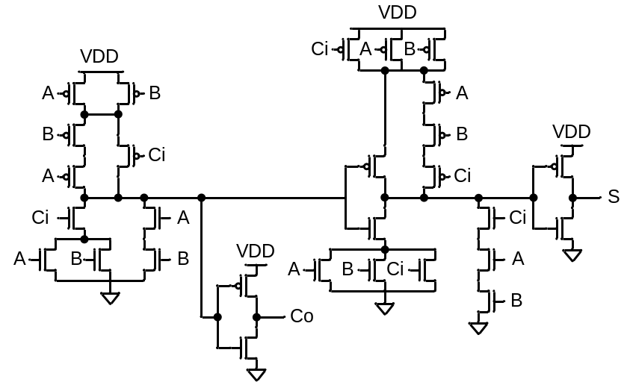
(Reference Full-Adder Circuit, NOT Dynamic CKT)

- The input signal rising/falling time is 0.5ns. The output loading is 0.5pf. Please design the 3-input pass-transistor A*B+C*(B*D+A*E) with the same delay time as 1ns for various input patterns. (0.3ns < T000, T001, T010, T011, T100, T101, T110, T111 < 0.7ns)

- The input signal rising/falling time is 0.5ns. The output loading of A=B, A>B, and A<B are all 0.5pf. Please design the comparator by using pseudo-nMOS with the same rising time and falling time as 1ns. (0.8ns < T₀₀, T₀₁, T₁₀, T₁₁ < 1.2ns)
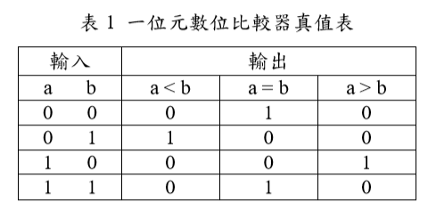
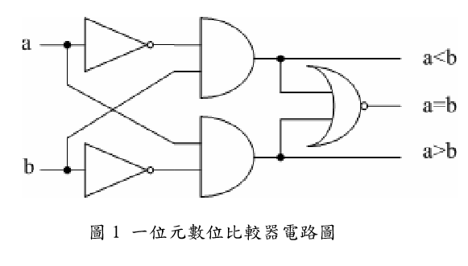
- The input signal rising/falling time is 0.5ns. The output loading of A=B, A>B, and A<B are all 2pf. Please design the comparator by using pass-transistor with the same rising time and falling time as 1ns. (0.8ns < T₀₀, T₀₁, T₁₀, T₁₁ < 1.2ns)

- The input signal rising/falling time is 0.5ns. The output loading is 2pf. Please design the circuit by using pass-transistor with the same rising time and falling time as 1ns. (0.8ns < T₀₀, T₀₁, T₁₀, T₁₁ < 1.2ns)

